**DOCKER IMAGE BUILD USING JENKINS**

**Step 1 :- Configure Jenkins on Linux using this command**

**sudo yum install jenkins -y**

**Step 2 :- Start the Jenkins service**

**Sudo service jenkins start/restart/status/stop**

**Step 3 :- Create your account on Jenkins**

**-> Open a browser then enter URL (http://HostIP:port)**

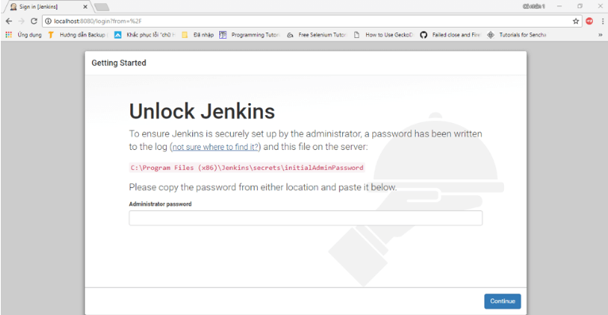

**To unlock Jenkins, copy the password from the file at C:\Program Files (x86)\Jenkins\secrets\initialAdminPassword and paste it in the Administratorpassword field. Then, click the "Continue" button.**

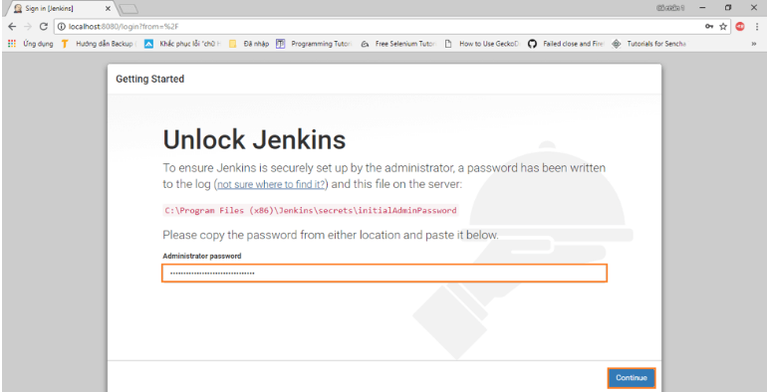

After that choose install suggested plugins.

Then, this window get appears.

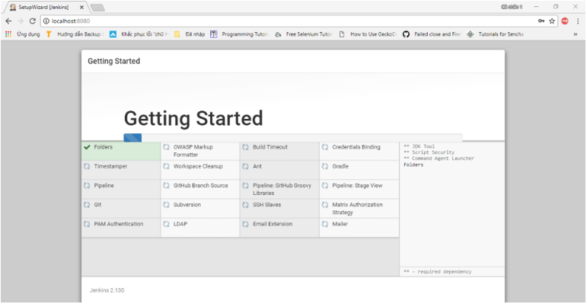

The next thing we should do is create an admin user for Jenkins. Put in your details and click ****"Save and Continue."****

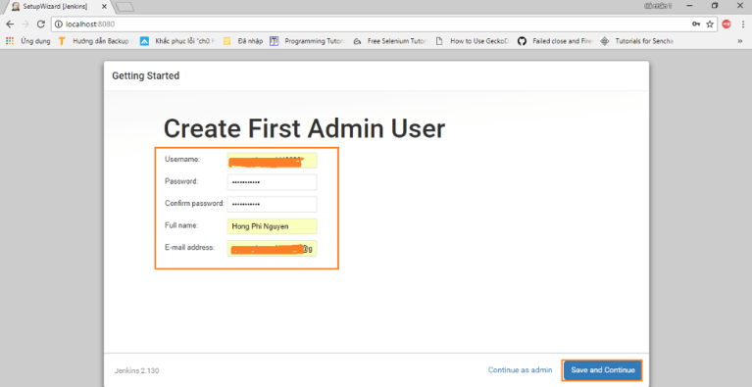

Click ****"Save and Finish"**** to complete the Jenkins installation.

Now, click ****"Start using Jenkins"**** to start Jenkins.

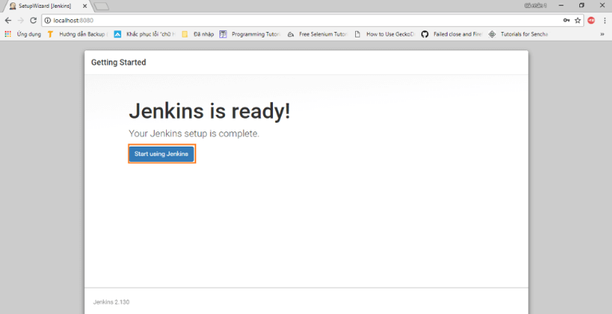

Finally, here is the default Jenkins page.

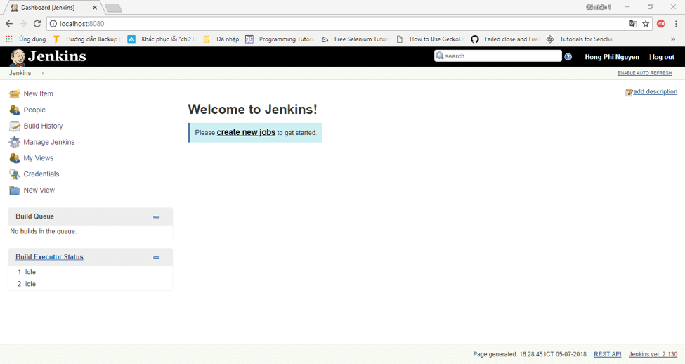

Step 4:- select a new item then enter the item name and select freestyle project.

Click OK button.

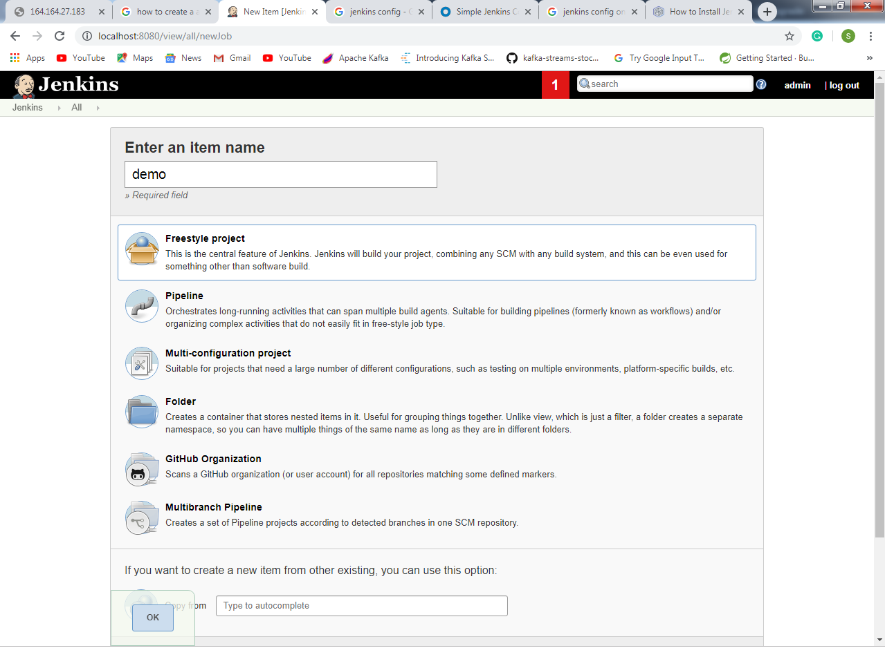

Select the you git project and enter git repository URL.

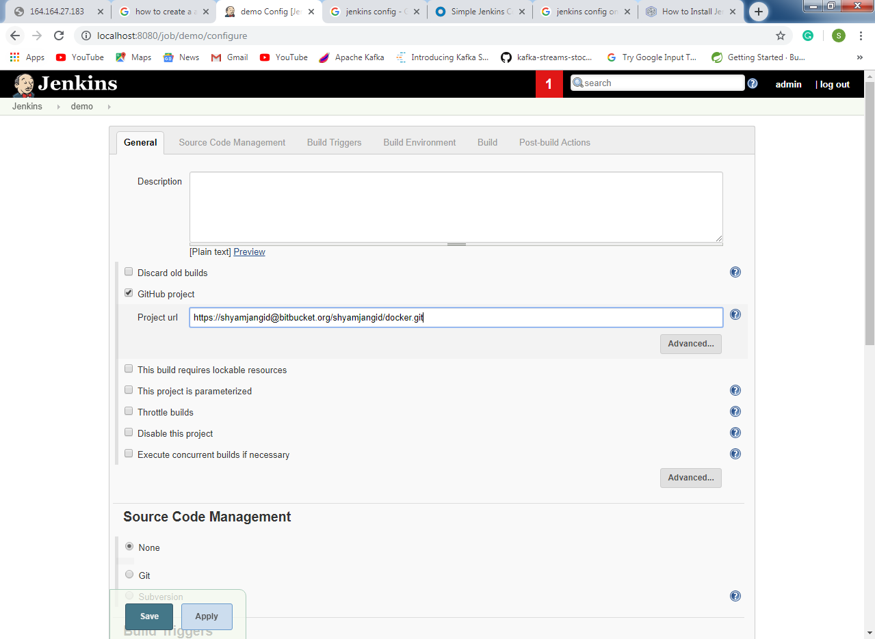

In source code management section select git option enter the git repository URL. And add the git credential.

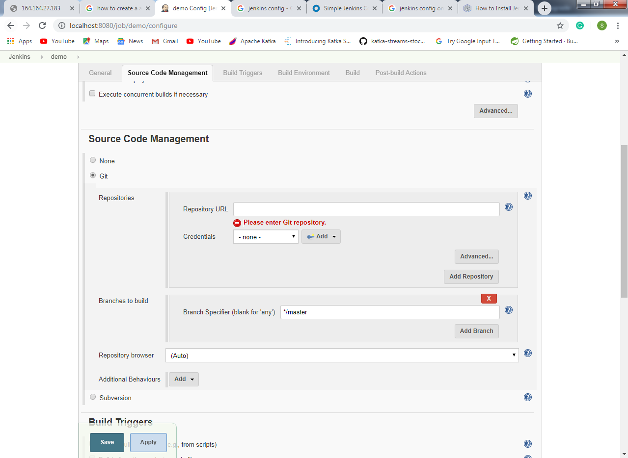

In build section ” add build step ” ->> Invoke top-level maven target.

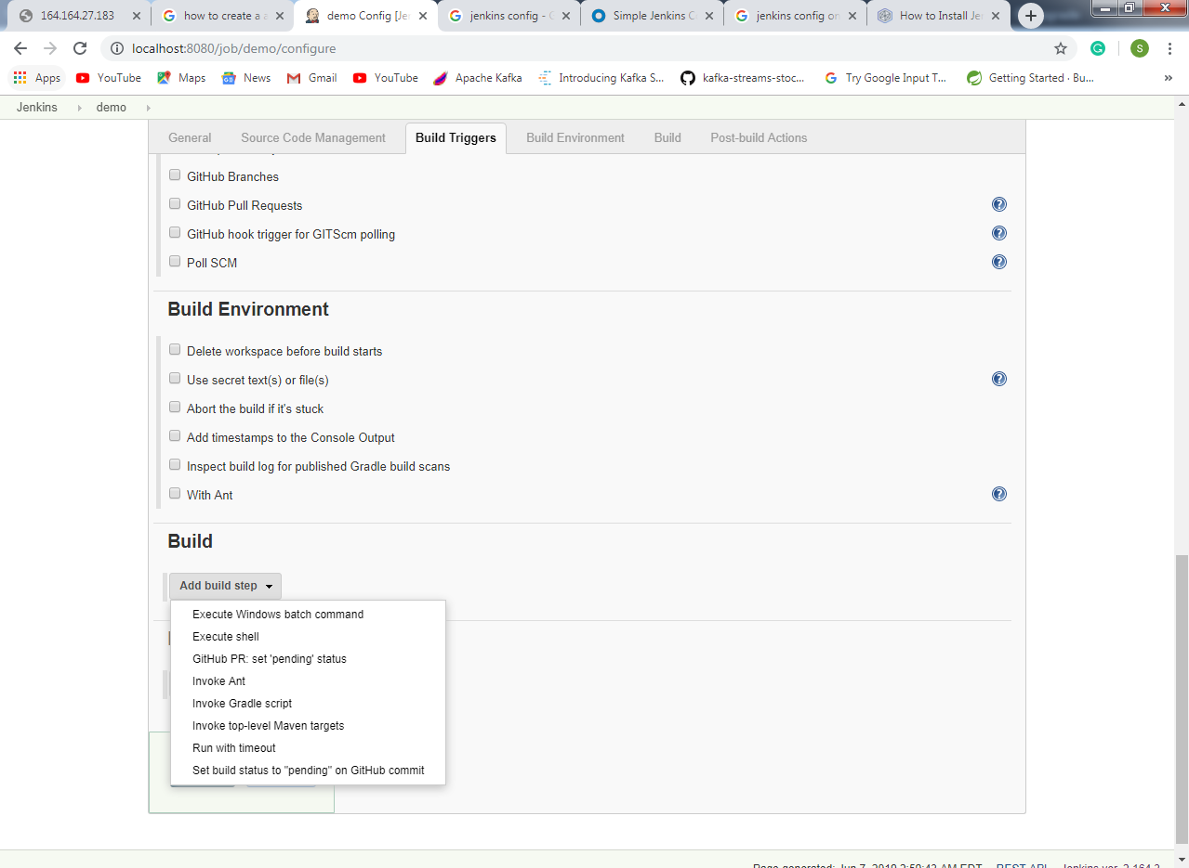

Add the goal “clean package dockerfile:build” and press save button.

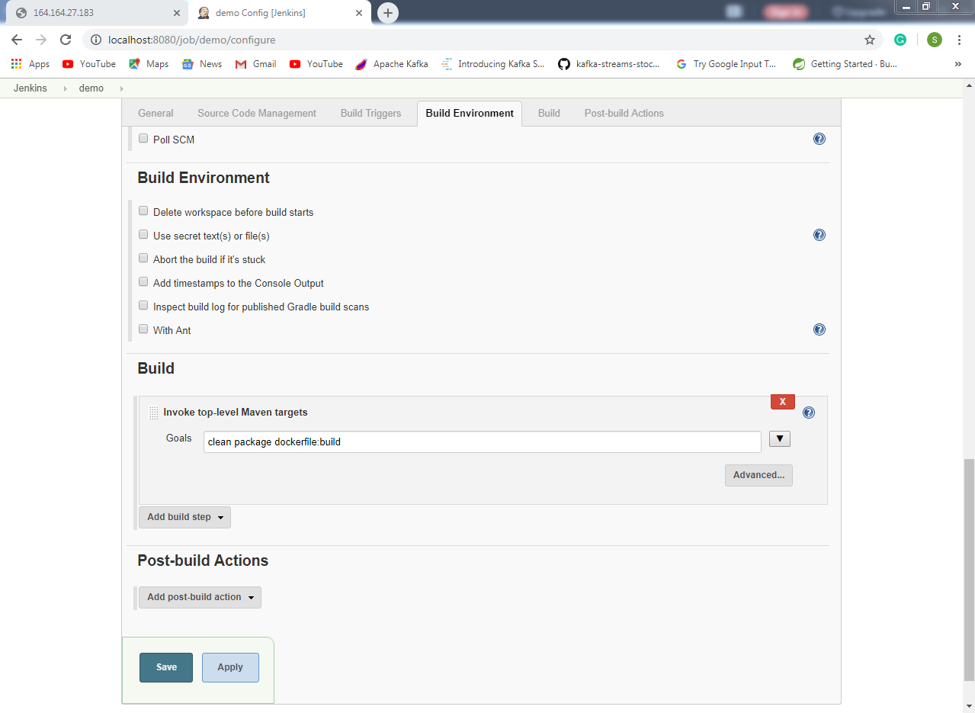

Then press the build now option.

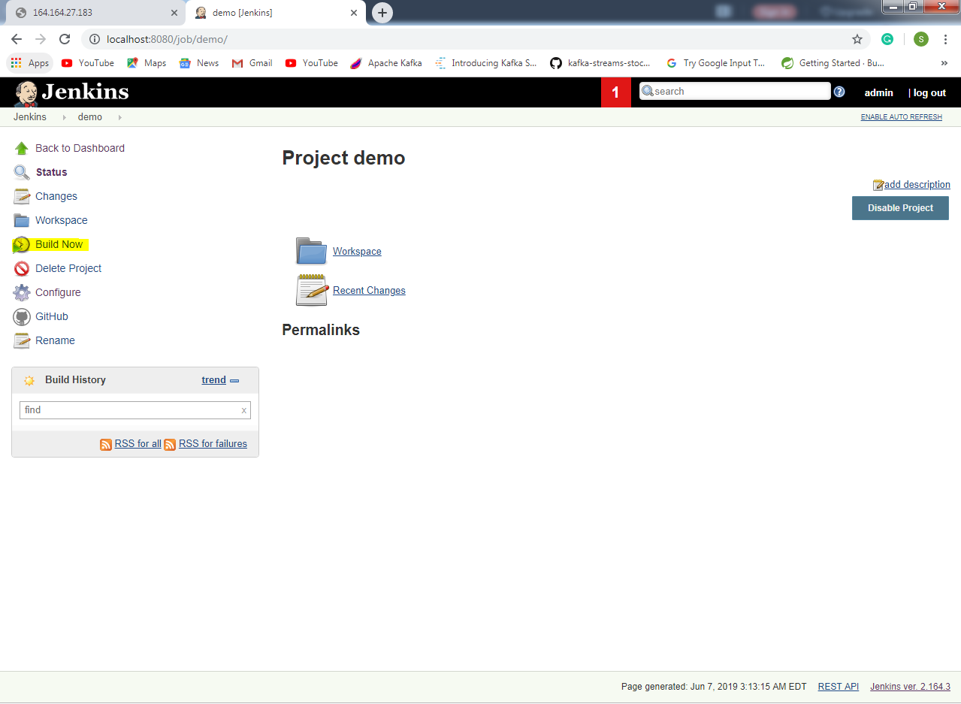

Then press console output to see the output

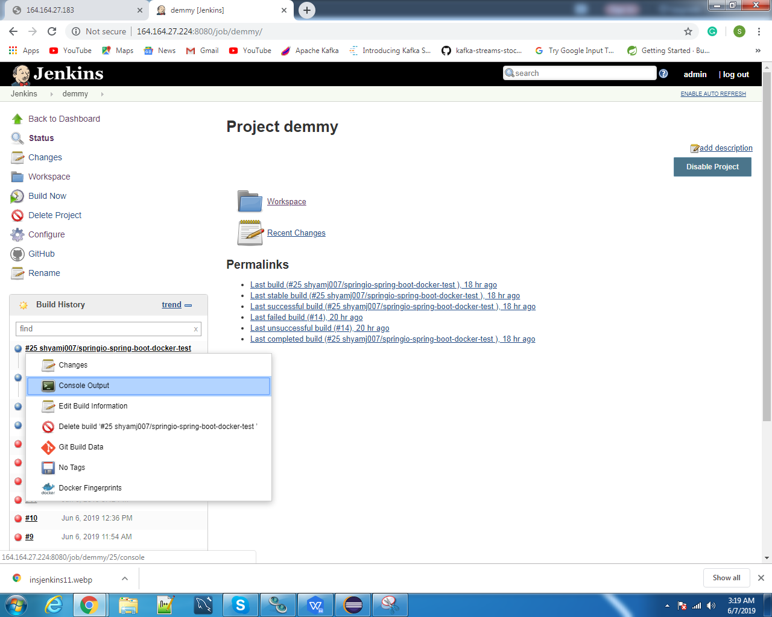

Here is the build success screen.

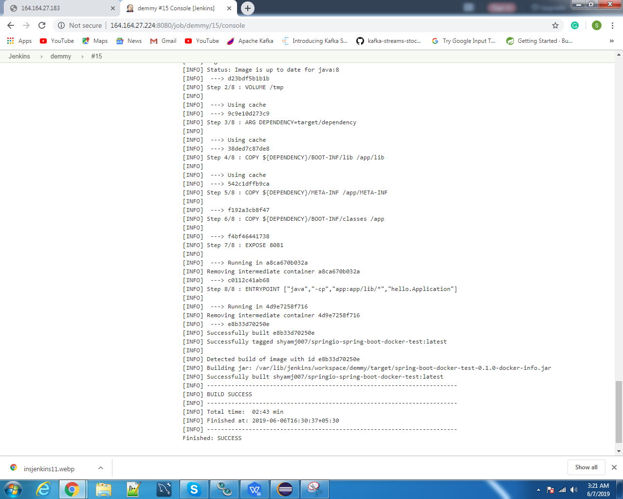

**Note**:- If the permission denied error is arise then grant the permission to the jenkins folder on the linux terminal by using this command “ **sudo usermod -aG docker jenkins** ”

Step 5:- For push docker image on docker hub

1. Select **back to dashboard**
2. Select **manage Jenkins**.
3. Select **manage plugins**.
4. Select **available tab.**
5. Search **cloudbees plugins** and **install it with restart Jenkins.**

Step 6:- Open project configure and add **Build** with **Docker Build & Publish(**Add Docker Hub Repository Name & set the credentials of your docker hub**)**. After this add another build goal **Execute Shell**.

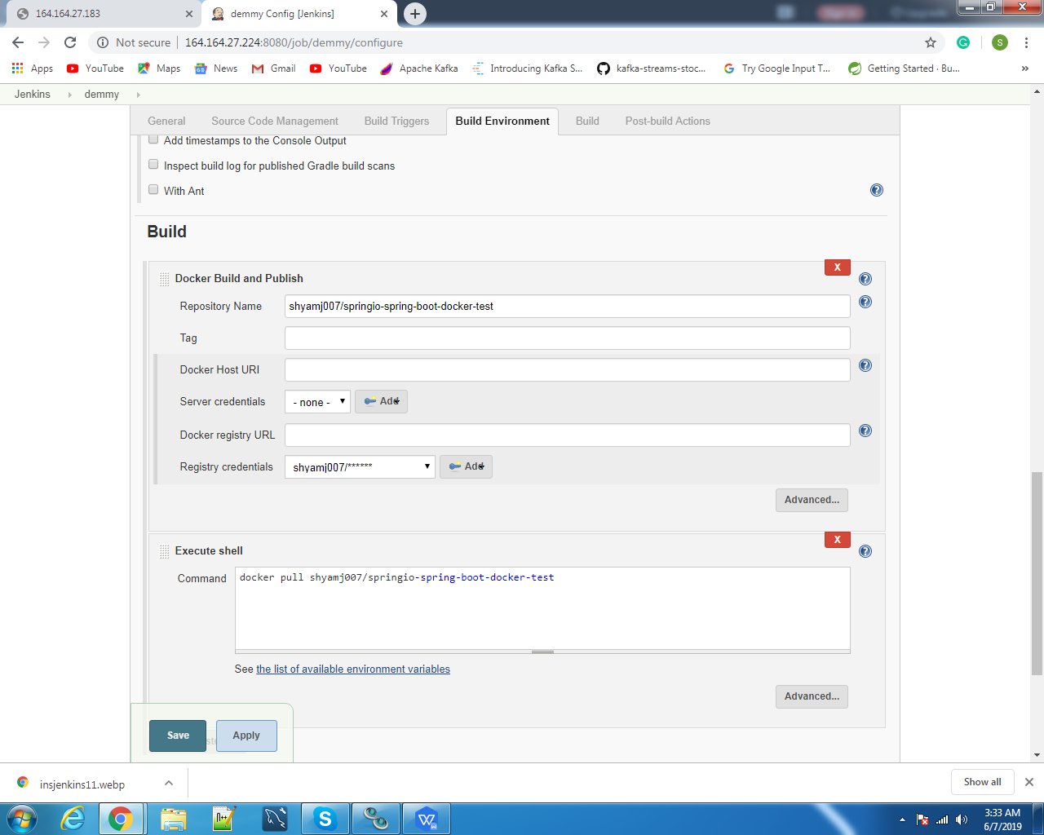

Then save it and build it. After build success add a new build goal of execute shell using this command “**docker run image_ name/id**”. And see the output on browser.